**ROCK IDENTIFICATION USING DEEP CONVOLUTION NEURAL NETWORK**

A Project Report Submitted to

**Jawaharlal Nehru Technological University, Hyderabad**

In partial fulfilment for the requirement for the award of B-Tech Degree in Computer Science and Engineering

SUBMITTED BY

**Ravula Karthik Reddy 17UK1A05J3**

**Mohammed Farha Nousheen 17UK1A05K8**

**Madiha Razeen 17UK1A05E1**

Under the esteemed guidance of

M. Pavan kumar

Associate Professor



**DEPARTMENT OF COMPUTER SCIENCE & ENGINEERING**

**DEPARTMENT OF COMPUTER SCIENCE AND ENGINEERING**

**VAAGDEVI ENGINEERING COLLEGE**

**Warangal**



**CERTIFICATE**

This is to certify that the Mini Project Report entitled **“ROCK IDENTIFICATION USING DEEP CONVOLUTION NEURAL NETWORK”** is submitted ***by Ravula Karthik Reddy (17UK1A05J3), Mohammed Farha Nousheen (17UK1A05K8), Madiha Razeen (17UK1A05E1)*** in partial fulfilment of the requirements for the award of the degree of Bachelor of Technology in Computer Science and Engineering during the academic year 2021-2021

**Project Guide Head of the department**

**M. Pavan Kumar Dr Naveen Kumar Rangaraju**

**External Examiner**

**ACKNOWLEDGEMENT**

We express our gratitude to our principal Dr Prasad Rao who permitted us to carry project work as apart of academics.

We would like to thanks Dr Naveen Kumar Rangaraju, Head of the department of CSE, for his support and encouragement in completing our project. We would like to express our gratitude to our project guide.

We proudly thank our project Guide MR. M. Pavan Kumar, Assistant Professor, Vaagdevi Engineering College for her co-operation throughout the project.

We would also express our sincere thanks to all staff members of Vaagdevi Engineering College for their kind co-operation and timely help during our academic career.

Finally, we wish to take this opportunity to express our deep gratitude to our family members and all the people who have extended their co-operation in various ways during our project work.

**RAVULA KARTHIK REDDY (17UK1A05J3)**

**MOHAMMED FARHA NOUSHEEN (17UK1A05K8)**

**MADIHA RAZEEN (17UK1A05E1)**

**ABSTRACT**

In the geological survey, the recognition and classification of rock lithology are an important content. The recognition method based on rock thin section leads to long recognition period and high recognition cost, and the recognition accuracy cannot be guaranteed. Moreover, the above method cannot provide an effective solution in the field. As a communication device with multiple sensors, smartphones are carried by most geological survey workers. In this paper, a smartphone application based on the convolutional neural network is developed. In this application, the phone’s camera can be used to take photos of rocks. And the types and lithology of rocks can be quickly and accurately identified in a very short time. This paper proposed a method for quickly and accurately recognizing rock lithology in the field. Based on ShuffleNet, a lightweight convolutional neural network used in deep learning, combined with the transfer learning method, the recognition model of the rock image was established. The trained model was then deployed to the smartphone. A smartphone application for identifying rock lithology was designed and developed to verify its usability and accuracy. The research results showed that the accuracy of the recognition model in this paper was 97.65% on the verification data set of the PC. The accuracy of recognition on the test data set of the smartphone was 95.30%, among which the average recognition time of the single sheet was 786 milliseconds, the maximum value was 1,045 milliseconds, and the minimum value was 452 milliseconds. And the single-image accuracy above 96% accounted for 95% of the test data set. This paper presented a new solution for the rapid and accurate recognition of rock lithology in field geological surveys, which met the needs of geological survey personnel to quickly and accurately identify rock lithology in field operations.

**CHAPTER – 01**

**INTRODUCTION**

**1. INTRODUCTION**

In the mining process of underground metal mines, the misjudgment of rock types by on-site technicians will have a serious negative impact on the stability evaluation of rock mass and the formulation of support schemes, which will result in the loss of economic benefits and potential safety hazards of mining enterprises. In order to realize the precise and intelligent identification of rock types, the image data of blue calcite, limestone, marble, olivine and red crystal, are amplified.

The recognition of rocks is not only an important part of geological survey but also the focus of geological research. The traditional recognition method consists of three steps [1, 2]: firstly, workers collect fresh rock samples in the process of exploration; secondly, after returning to the laboratory, the rock thin section with an area of about 2 × 2 cm is cut from the vertical stratification direction of the rock samples. When one side of the rock samples has been flattened on the grinding machine, it is glued to the carrier glass with glue such as adhesive. Then, the thickness of the other side is smoothed to 0.03 mm, and the cover glass piece is glued with the adhesive.

Finally, an image of the rock sheet is viewed under a polarizing microscope by a knowledgeable or experienced geologist. In this way, the rock type and structural parameters can be determined. This traditional identification method requires the observer to have very rich geological knowledge and experience. In addition, the method has many problems, such as strong subjectivity, long identification period, and poor field identification ability.

With the development of computer vision and image processing technology, great changes have been brought to rock recognition and mineral analysis.

Many researchers analyzed the texture, fabric, granularity, and lithology of rocks based on image processing techniques such as image analysis and feature extraction. Patel used the probabilistic neural network (PNN) to develop a lab-scale vision-based model in which color histogram features are used as the input. The model has achieved good recognition results, and the error of misclassification of limestone is less than 6%.The main limitation of this study is that the classification object is the entire rock sample of multiple rocks, and no further consideration is applied to identify rocks on site.

The accuracy of rock identification is 98.5%. However, the identification objects of this study are rock thin section images, which need to be made in the laboratory and cannot be directly applied to the work site. Based on computer vision and machine learning, Marmoreal. used more than 1,000 carbonate flakes. Based on the gray scale digital image, they set up the multilayer sensory neural network model. Then, network training based on texture data was carried out, and the classification accuracy reached 93.3%.

Guo Chao et al. used the original color image of the rock to describe the feature space. Their method was to calculate the standard arithmetic values of different color channels by combining their morphologies [16]. The neural network is used to establish the mapping relationship between the feature space and the rock image category, and the algorithm is tested using 100 rock thin section images from the Ordos Basin. The results show that the automatic recognition rate of rock images in different color spaces is more than 95%.

The above research on rock image recognition uses the standard rock thin section image, rather than taking the more complex and direct rock image as the research object.

**1.1 OVERVIEW**

A tremendous interest in deep learning has emerged in recent years. The most established algorithm among various deep learning models is convolutional neural network (CNN), a class of artificial neural networks that has been a dominant method in computer vision tasks since the astonishing results were shared on the object recognition. Geological research is no exception, as CNN has achieved expert-level performances in various fields Needless to say, there has been a surge of interest in the potential of CNN among geological researchers, and several studies have already been published in areas such as mineral detection using satellite images, classification of geographical terrains, image reconstruction of ocean bed and unreachable places, etc. Familiarity and utilization of this methodology would help not only researchers who apply CNN to their tasks in geology, but also the common men and farmers to identify and understand the local geology , as deep learning may influence their practice in the near future. This article focuses on the creating a rock classifier using the concepts of CNN.

**1.2 PURPOSE**

The automated interpretation of rock structure can improve the efficiency, accuracy, and consistency of the geological risk assessment and better utilization of resources. Because of the high uncertainties in the geological images as a result of different regional rock types, as well as in-situ conditions (e.g., temperature, humidity, and construction procedure), previous automated methods have limited performance in classification of rock. This project presents a framework for classifying multiple rock structures based on the geological images of tunnel face using convolutional neural networks (CNN). A prototype recognition system is implemented to classify 5 types of rock structures including blue calcite, limestone, marble, olivine and red crystal. These are the major rock types found in Indian Subcontinent.

Meanwhile, the model trained by a large database can obtain the rock features more comprehensively, leading to higher accuracy. Compared with the original classification method, the image classification method is closer to the reality considering both the accuracy and the perspective of error divergence. The experimental results reveal that the proposed method is optimal and efficient for automated classification of rock structure using the geological images of the rocks

|  |  |  |
| --- | --- | --- |
| |  | | --- | |  |   **CHAPTER – 02**  **LITERATURE SURVEY** | https://mail.google.com/mail/u/0/images/cleardot.gif  https://mail.google.com/mail/u/0/images/cleardot.gif |
|  |

**2. LITERATURE SURVEY**

|  |  |  |  |  |
| --- | --- | --- | --- | --- |
| **S.NO.** | **TITLE OF THE PAPER & YEAR**  **PUBLISHED** | **TECHNIQUES USED** | **RELEVANCE** | **FUTURE SCOPE** |
| 1 | Image classification using artificial  neural networks: An experimental study on Corel database  2011 | Artificial neural  Network, back propagation. | In this paper high-level image classes are inferred from low-level image features like color and shape features with the help of artificial neural network. Back propagation neural network algorithm is used for integrating knowledge as well. Back propagation neural network algorithm is used for integrating knowledge as well. | The algorithm has a fairly low accuracy of 83.21%. We can use optimization techniques to make the model more efficient |
| 2 | Artificial neural networks and other methods of image classification  2007 | Artificial Neural  Networks (ANN),  Support Vector  Machines (SVM),  Fuzzy measures, Genetic Algorithms (GA), Fuzzy support Vector Machines (FSVM) | Demonstrates different accuracy values for traditional classification methods | Improve the automatic techniques, and apply CNNs for a higher accuracy result. This paper also fails to consider overfitting between different models |
| 3 | Convolutional Neural Network (CNN) for Image Detection and Recognition  2006 | CNN | Uses CNN to demonstrate classification of a UCI lung cancer dataset | Try to improve the algorithm through heuristic algorithms. |
| 4 | Design of Artificial Neural Network Architecture for  Handwritten Digit Recognition on FPGA  2016 | layer feed-forward artificial neural network | Optimizes the regular neural network using node pruning and tree pruning | N/A |
| 5 | Computational Complexity of Neural Networks: A Survey  2011 | ANN, CNN, ANN With back  propagation | This paper compares the time complexity of various neural networks for image classification | N/A |
| 6 | Pruning Convolutional Neural Networks for Image Instance Retrieval  2010 | CNN, node pruning | In this paper CNNs are optimized by pruning them. This comes at a loss of accuracy but results in the neural network to be 3% faster for large datasets over 35000 entries | Different ways of optimization can be tried which lead to lesser loss of accuracy. |
| 7 | Deep Convolutional Neural Networks for Image  classification 2014 | Deep convolutional neural network, and small text mining | It exploits the use of neural network for performing sentiment analysis which is the aim of my project based on facial expressions | Improving the accuracy of the model by providing a mask for less significant features to aid in error detection in the model. |
| 8 | Improving optimization of convolutional neural networks through parameter fine-tuning  2019 | CNN,  hyper parameter tuning | This model compares the original CNN built and tests it against an optimized version of the same network by using parameter tuning method and feature reduction | As this is a comparative study not much is to be improved  . |
| 9 | Optimization of convolutional neural network parameters for image classification  2017 | CNN | Method is proposed to make an improvement on the accuracy of the CNN by two means. One is by increasing the number of layers and another is to reduce the image size of the window. | As this is a comparative study not much is to be improved. |
| 10 | Very deep  convolutional neural network  based image classification using small training sample size  2015 | CNN, Regularization, Batch normalization | Uses regularization and batch normalization on CNN to fit small datasets with simple and proper modifications and don't need to re-design specific small networks. | We can think of optimizing the overfitting problem by removing some of the nodes in the network to make it slightly lightweight. |

**2.1 EXISTING PROBLEM**

Rocks are a fundamental component of Earth. The automatic identification of rock type in the field would aid geological surveying, education, and automatic mapping. It is a basic part of geological surveying and research, and mineral resources exploration. The automatic identification of rock type in the field would aid geological surveying, education, and automatic mapping. Working conditions in the field generally limit identification to visual methods, including using a magnifying glass for fine-grained rocks. Visual inspection assesses properties such as color, composition, grain size, and structure. The attributes of rocks reflect their mineral and chemical composition, formation environment, and genesis. The color of rock reflects its chemical composition. But these analysis is time taken process to identify the rocks. Its application here has effectively identified rock types from images captured in the field. This paper proposes an accurate approach for identifying rock types in the field based on image analysis using deep convolutional neural networks.

**2.2 PROPOSED SOLUTION**

Deep learning is receiving significant research attention for pattern recognition and machine learning. Its application here has effectively identified rock types from images captured in the field. This paper proposes an accurate approach for identifying rock types in the field based on image analysis using deep convolutional neural networks. The results show that the proposed approach based on deep learning represents an improvement in intelligent rock-type identification and solves several difficulties facing the automated identification of rock types in the field. Who are experienced in the field of geological they can identify the rocks easily. But who are new to the field, it can help to identify the type of rock.

**CHAPTER – 03**

**DESIGN**

**3. THEORETICAL ANALYSIS**

Under the Tensorflow deep learning framework, the Faster R-CNN rock type identification model was constructed by using Python programming language. Finally, the model was trained by GPU acceleration. The iterations of the whole training process is 5,000 times.

The dataset includes 5 kind’s rock with different lithology’s, such as including blue calcite, limestone, marble, olivine and red crystal. To reduce the parameters of the model, we reduce the size of each rock image to 64∗64 pixels on the premise of ensuring accuracy

**3.1 BLOCK DIAGRAM**

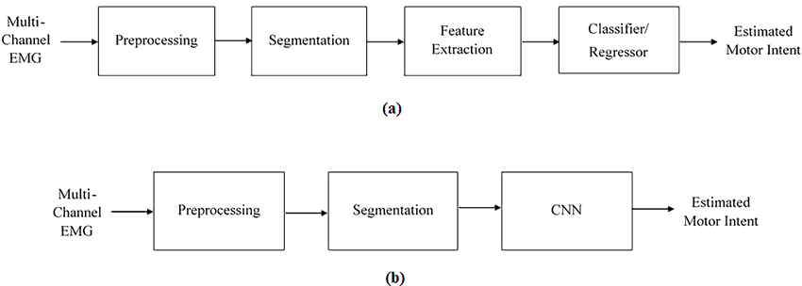

**3.2 SOFTWARE ANALYSIS**

* Jupyter Notebook Environment
* Spyder Ide
* Python ()
* HTML
* Flask

We developed this Rock Identification model by using the Python language which is a interpreted and high level programming language. For coding we used the Jupyter Notebook environment of the Anaconda distributions and the Spyder, it is an integrated scientific programming in the python language.

For creating user interface for the prediction we used the Flask. It is a micro web framework written in Python. It is classified as a micro framework because it does not require particular tools or libraries. It has no database abstraction layer, form validation, or any other components where pre-existing third-party libraries provide common functions, and a scripting language to create a webpage is HTML by creating the templates to use in the functions of the Flask and HTML.

**3.3. FLOWCHART**

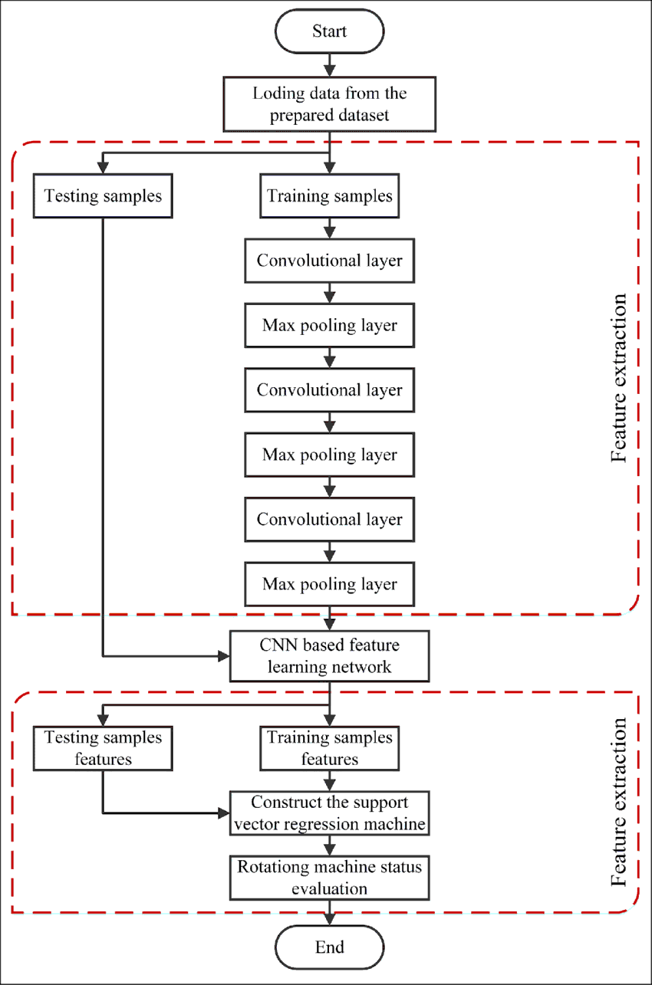

**CHAPTER – 04**

**RESULTS**

**4. RESULT**

It shows whether the predicted image is blue calcite, limestone, marble, olivine, red crystal

**ADVANTAGES AND DISADVANTAGES**

**Advantages:**

The main **advantage of CNN** compared to its predecessors is that it automatically detects the important features without any human supervision. For example, given many pictures of cats and dogs, it can learn the key features for each class by itself

**Disadvantages:**

* **CNN** do not encode the position and orientation of object.
* Lack of ability to be spatially invariant to the input data

**APPLICATIONS**

**CHAPTER – 05**

**CONCLUSION AND FUTURE SCOPE**

**5. CONCLUSION:**

The classification of trash within the scope of recycling is possible with machine learning methods. Further data are needed to achieve higher accuracy rates. In the context of our proposed model, we have achieved high classification success without using any method of data augmentation. Studies show that the number of images and classes in the data set can be increased and a more comprehensive recycling project can be realized

**5.1. FUTURE SCOPE:**

It can reduce the man power and can also can prevent humans and animals in spreading of diseases due to the waste material

**APPENDIX**

**HTML:**

<html lang="en">

<head>

<meta charset="UTF-8">

<meta name="viewport" content="width=device-width, initial-scale=1.0">

<meta http-equiv="X-UA-Compatible" content="ie=edge">

<title>Gesture Recognition System</title>

<link href="https://cdn.bootcss.com/bootstrap/4.0.0/css/bootstrap.min.css" rel="stylesheet">

<script src="https://cdn.bootcss.com/popper.js/1.12.9/umd/popper.min.js"></script>

<script src="https://cdn.bootcss.com/jquery/3.3.1/jquery.min.js"></script>

<script src="https://cdn.bootcss.com/bootstrap/4.0.0/js/bootstrap.min.js"></script>

<link href="{{ url_for('static', filename='css/main.css') }}" rel="stylesheet">

<style>

.bg-dark {

background-color: #42678c!important;

}

#result {

color: #0a1c4ed1;

}

</style>

</head>

<body>

<nav class="navbar navbar-dark bg-secondary">

<div class="container">

<a class="navbar-brand" href="#">Rock Identification Using CNN</a>

</div>

</nav>

<div class="navbar navbar-dark bg-warning">

<div id="content" style="margin-top:2em">

<div class="container">

<div class="row">

<div class="col-sm-6 bd" >

<h3>Rock Identification</h3>

<br>

<p>Image segmentation and classification is more and more being of interest for computer vision and machine learning researchers. Many systems on the rise need accurate and efficient segmentation and recognition mechanisms. This demand coincides with the increase of computational capabilities of modern computer architectures and more effective algorithms for image recognition. The use of convolutional neural networks for the image classification and recognition allows building systems that enable automation in many industries. This article presents a system for classifying plastic waste, using convolutional neural networks. The problem of segregation of renewable waste is a big challenge for many countries around the world. Apart from segregating waste using human hands, there are several methods for automatic segregation. The article proposes a system for classifying waste with the following classes: polyethylene terephthalate, high-density polyethylene, polypropylene and polystyrene. The obtained results show that automatic waste classification, using image processing and artificial intelligence methods, allows building effective systems that operate in the real world.

</p>

<img src="https://cdn.dnaindia.com/sites/default/files/styles/full/public/2014/08/11/258167-garbage.jpg" style="height:250px"class="img-rounded" alt="Gesture">

</div>

<div class="col-sm-6">

<div>

<h4>Please upload a partical image</h4>

<form action = "<http://localhost:5000/predict>" id="upload-file" method="post" enctype="multipart/form-data">

<label for="imageUpload" class="upload-label">

upload image

</label>

<input type="file" name="image" id="imageUpload" accept=".png, .jpg, .jpeg">

</form>

<div class="image-section" style="display:none;">

<div class="img-preview">

<div id="imagePreview">

</div>

</div>

<div>

<button type="button" class="btn btn-info btn-lg " id="btn-predict">click on this to view which particle it is!!</button>

</div>

</div>

<div class="loader" style="display:none;"></div>

<h3>

<span id="result"> </span>

</h3>

</div>

</div>

</div>

</div>

</div>

</div>

</body>

<footer>

<script src="{{ url_for('static', filename='js/main.js') }}" type="text/javascript"></script>

</footer>

</html>

**APP.PY:**

from flask import Flask, redirect, url_for, request, render_template

from werkzeug.utils import secure_filename

from gevent.pywsgi import WSGIServer

# Define a flask app

app = Flask(__name__)

# Model saved with Keras model.save()

MODEL_PATH = 'models/Rock identification.h5'

# Load your trained model

model = load_model(MODEL_PATH)

# Necessary

# print('Model loaded. Start serving...')

# You can also use pretrained model from Keras

# Check <https://keras.io/applications/>

#from keras.applications.resnet50 import ResNet50

#model = ResNet50(weights='imagenet')

#model.save('')

print('Model loaded. Check <http://127.0.0.1:5000/'>

@app.route('/', methods=['GET'])

def index():

# Main page

return render_template('index.html')

@app.route('/predict', methods=['GET', 'POST'])

def upload():

if request.method == 'POST':

# Get the file from post request

f = request.files['file']

# Save the file to ./uploads

basepath = os.path.dirname(__file__)

file_path = os.path.join(

basepath, 'uploads', secure_filename(f.filename))

f.save(file_path)

img = image.load_img(file_path, target_size=(64, 64))

x = image.img_to_array(img)

x = np.expand_dims(x, axis=0)

with graph.as_default():

preds = model.predict_classes(x)

index = ['blue calcite','limestone','marble','olivine','red crystal']

text = "prediction : "+index[preds[0]]

# ImageNet Decode

return text

if __name__ == '__main__':

app.run(debug=False,threaded = False)